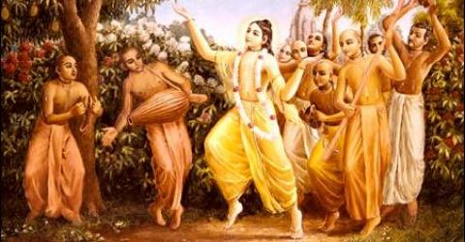

SOLDIERS OF GODHEAD
MAY 2010 edition
Order your free monthly edition on soldiersofgodhead@yahoo.com.

CONTENTS

- Meaning of Hare Krishna Mahamantra. Pg 3

- Lord Sri Krishna Chaitanya Mahaprabhu. Pg 6

- Shikastaka pg 8

- Srimad Bhagavad Gita pg 16

- Our constitutional position. Pg 18

Meaning of Hare Krishna Mahamantra

The Hare Krishna Mahamantra-HARE KRISHNA HARE KRISHNA KRISHNA KRISHNA HARE HARE/HARE RAM HARE RAM RAM RAM HARE HARE is a transcendental vibration with Hare, Krishna and Ram forming its beej mantra. Hara is the para shakti (Ma Durga) who eliminates all material desires and contamination in the heart of the devotee and takes him back home, back to Godhead. Krishna is the supreme personality of Godhead and He is absolute. Absolute means there is no difference between Him, His name, form, pastimes, senses, body, mind, activities or places of His varied activities. Whereas, in case of us human beings, our body, mind, senses, activities etc. are all different. When one prays to Krishna’s picture or idol, one is actually rendering personal service to Krishna as the picture or idol of Krishna is Krishna himself. This form of Krishna is his archa vigraha form. He is personally present where His pictures, idols or names are present. Hence, when one takes the name of Krishna, one is not taking the name of Krishna but is directly referring to Krishna the supreme personality of Godhead. Further, there is no difference between Ram and Krishna as both are one and the same. Ram is the incarnation of Krishna in the Raghu (sun) dynasty whereas Krishna is the original personality of Godhead as will be explained in the last article of this edition. Thus, when one chants the Hare Krishna Mahamantra- HARE KRISHNA HARE KRISHNA KRISHNA KRISHNA HARE HARE/HARE RAM HARE RAM RAM RAM HARE HARE, one is making an transcendental appeal to God and His superior energy to cleanse his mind and sense from material contamination and develop pure love for God. This method of God realization was popularized by Lord Chaitanya Mahaprabhu in West Bengal, India in the 15th century A.D.
Hare Krishna!

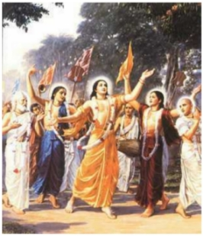
Lord Sri Chaitanya Mahaprabhu along with his principle associates conducting sankirtana.

Lord Sri Krishna Chaitanya Mahaprabhu.

Born as Vishvambar Mishra on the night of February 18th 1486 in Navadvip, West Bengal, India to Jagannath Mishra and Sachi devi, He was the incarnation of Lord Sri Krishna Himself in the Kali Yuga. The Lord had taken this form to explain to mankind the right method of offering loving devotional service in the lotus feet of God. When he was only an infant he would cry unstoppably until people around him would chant Hari bol. When he was 13 years old his father died and he went for the final rites of his father on the banks of River Ganga where he met his guru Sri Ishvarpuri. He instructed young Visvambar in the matter of the shastras and later told him to simply chant the holy name of God instead of studying the shastras as he was too foolish to understand them. Actually, through this lila God has thought His devotees that it is not knowledge that makes a devotee a devotee but bhakti which develops gradually from continuous chanting of the names of God. The purpose of all vedic knowledge and instructions is to understand God and chant His holy names, which gradually develops love and devotion in the heart of the jive atma. Development of devotion is the conclusion of all vedic wisdom. Because without devotion, forget liberation even a peaceful and happy life is not possible in this material world. When the Lord returned to his village, he had been transformed from a boy who was expert in outwitting others in arguments into a pure devotee of Lord Krishna and began singing and chanting His holy names in the village. At the age of 24 when his wife died, he agreed to remarry at the request of his aged mother and left his newly wedded wife, his small son and old mother to take to the renounced order of life (sanyasa). The next half of his life was spent in travelling the length and breadth of India, popularizing the chanting of the Hare Krishna Mahamantra and bringing bewildered people on the path of devotion until his death at the age of 48 in Jagannathpuri. The followers of Lord Chaitanya Mahaprabhu are known as Gaudiya Vaishnavs and follow the teachings of Lord Sri Krishna in the Srimad Bhagavad Gita and the teachings of the six Goswamis of Vrindavan who were the principle associates and students of Lord Chaitanya Mahaprabhu.
Hare Krishna!

Shikastaka

— The Eight Instructions of Sri Chaitanya Mahaprabhu —
Lord Chaitanya Mahaprabhu (1486-1535) is the most recent incarnation of the Supreme Personality of Godhead Sri Krishna. He appeared 500 years ago in Navadvip, West-Bengal and started His worldwide Sankirtan mission of propagating the chanting of the holy name of the Lord (the process of self-realization for this age - to meditate upon the sound of the maha-mantra: Hare Krishna Hare Krishna, Krishna Krishna Hare Hare, Hare Rama Hare Rama, Rama Rama Hare Hare). He left us only eight verses, called Siksastakam, in which His mission and precepts are revealed.
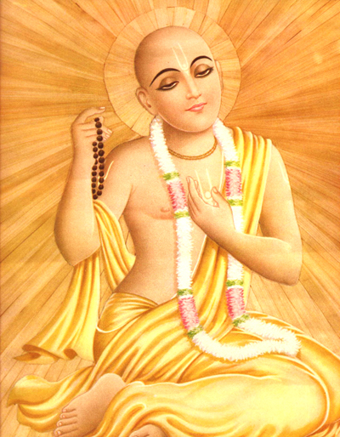
Sri Krishna Chaitanya Mahaprabhu (1486-1535)
Cited from "Teachings of Lord Chaitanya" Original version 1968
A. C. Bhaktivedanta Swami Prabhupada

Sri Siksastakam
Text 1
ceto-darpana-marjanam bhava-maha--davagni-nirvapanam
shreyah-kairava-chandrika-vitaranam vidya-vadhu-jivanam
anandambudhi-vardhanam prati-padam purnamritaswadanam
sarvatma-snapanam param vijayate sri-krishna-sankirtanam
Glory to the Sri Krishna Sankirtana, which cleanses the heart of all the dust accumulated for years and extinguishes the fire of conditional life, of repeated birth and death. This sankirtana movement is the prime benediction for humanity at large because it spreads the rays of the benediction moon. It is the life of all transcendental knowledge. It increases the ocean of transcendental bliss, and it enables us to fully taste the nectar for which we are always anxious.
Text 2
namnam akari bahudha nija-sarva-shaktis
tatrarpita niyamitah smarane na kalah
etadrishi tava kripa bhagavan mamapi
durdaivam idrisham ihajani nanuragaha
O my Lord, Your holy name alone can render all benediction to living beings, and thus You have hundreds and millions of names like Krishna and Govinda. In these transcendental names You have invested all Your transcendental energies. There are not even hard and fast rules for chanting these names. O my Lord, out of kindness You enable us to easily approach You by Your holy names, but I am so unfortunate that I have no attraction for them.
Text 3
trinad api sunichena
taror api sahishnuna
amanina manadena
kirtaniyah sada harih
One should chant the holy name of the Lord in a humble state of mind, thinking oneself lower than the straw in the street; one should be more tolerant than a tree, devoid of all sense of false prestige and should be ready to offer all respect to others. In such a state of mind one can chant the holy name of the Lord constantly.
Text 4
na dhanam na janam na sundarim
kavitam va jagad-isha kamaye
mama janmani janmanishvare
bhavatad bhaktir ahaituki twayi
O almighty Lord, I have no desire to accumulate wealth, nor do I desire beautiful women, nor do I want any number of followers. I only want Your causeless devotional service birth after birth.
Text 5
ayi nanda-tanuja kinkaram
patitam mam vishame bhavambudhau
kripaya tava pada-pankaja-
sthita-dhuli-sadrisham vichintaya
O son of Maharaja Nanda [Krishna], I am Your eternal servitor, yet somehow or other I have fallen into the ocean of birth and death. Please pick me up from this ocean of death and place me as one of the atoms at Your lotus feet.
Text 6
nayanam galad-ashru-dharaya
vadanam gadgada-ruddhaya gira
pulakair nichitam vapuh kada
tava nama-grahane bhavishyati
O my Lord, when will my eyes be decorated with tears of love flowing constantly when I chant Your holy name? When will my voice choke up, and when will the hairs of my body stand on end at the recitation of Your name?
Text 7
yugayitam nimeshena
chakshusha pravrishayitam
shunyayitam jagat sarvam
govinda-virahena me
O Govinda! Feeling Your separation, I am considering a moment to be like twelve years or more. Tears are flowing from my eyes like torrents of rain, and I am feeling all vacant in the world in Your absence.
Text 8
ashlishya va pada-ratam pinashtu mam
adarshanan marma-hatam karotu va
yatha tatha va vidadhatu lampato
mat-prana-nathas tu sa eva naparah
I know no one but Krishna as my Lord, and He shall remain so even if He handles me roughly by His embrace or makes me brokenhearted by not being present before me. He is completely free to do anything and everything, for He is always my worshipful Lord unconditionally.
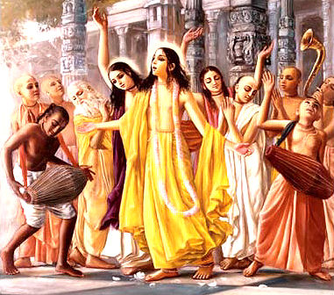

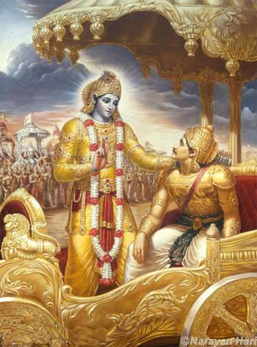
Lord Krishna instructing Arjun in the knowledge of the Gita.

Srimad Bhagavad Gita

The Bhagavad Gita or the songs sung by God Himself, is the crown jewel of the shastras and the legacy of India given to the world. It begins as a casual conversation between two friends Arjun and Krishna on the battle field of Kurukshetra and then turn into a conversation between a Guru and disciple and later into a conversation between God and His devotee. It is a philosophical text like no other. There is no text, book, or piece of philosophy which can compare in any way to the Bhagavad Gita. Since it is spoken by the Lord himself, every word of it is to be considered true as God is purushottama (perfect) and he does not lie. An ordinary human being is governed by the three modes of material nature namely- ignorance, passion and goodness. He is bound to suffer on three accounts-Adhiyatmik (suffering due to mind and body), Adibhoudik (suffering due to other people or creatures) and Adhidaivik ( suffering due to demigods). Man is also under the illusionary cover of Maya and thus considers himself as supreme and rejects the supremacy or even existence of God. But God is the creator of this illusion and thus cannot be illusioned. He is thus perfect in all respects. Hence, his words are the supreme truth.
Bhagavad Gita is not merely a religious text. It is a means for the deliverance of all of mankind. In the 66th verse of the 18th chapter of Bhagavad Gita, Lord Krishna tells Arjun to surrender all religions and only submit to His (Krishna’s) lotus feet. He promises to free him from all bondage and sufferings and grant him liberation and asks Arjun not to fear. It is thus evident that Bhagavad Gita is not a text confined to only Hindus but it is a universal text which can and must be accepted by people from all walks of life. Further, the Lord did not speak the Gita into Arjun’s ears. He spoke it in the middle of the armies of Kurus and Pandavs which means the knowledge of the Gita was for everyone on the battle field and not only for Arjun or the Pandavas. This proves the universality of the Gita and it is in every respect beneficial to anyone who reads or listens to it.
Hare Krishna!

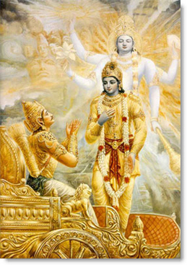
Lord Sri Krishna displaying His universal form to Arjun.

Our Constitutional Position
As Arjun learnt from the supreme personality of Godhead Krishna about the constitutional position of the jive atma (living entity) in relation to Him he accepted Krishna as God Himself and not as a mere human being. We jive atmas or living entities are parts and parcels of the supreme lord, but owing to being under the illusionary energy (maya) of God, we have forgotten our relationship with him and that forgetfulness is the source of our sufferings. The purpose of the valuable human birth is to understand that forgotten relationship and go back home, back to Godhead. But we simply waste it in sense gratification and lamenting for false and temporary pleasures. Pleasure is the driving force of our life. We are always in search for it but never get it in spite of all material comforts. We study because we want a good job, we want a good job so that we can marry a good person and have sufficient money. We want money for material comforts and material comforts for pleasure. So pleasure is what we want and that’s what we don’t get in this material and temporary world. But when one surrenders to Krishna and makes Him the goal of his life, Krishna free him from material bondage as confirmed in the Bhagavad Gita and grants him true pleasure. That’s why another name of Krishna is Govinda or the giver of pleasure. This pleasure is not false or temporary. It is permanent and everlasting. When one develops true love, devotion and affection for Krishna, one is freed from material sufferings and desires of sense gratification and all anxieties and goes back home, back to Godhead as confirmed in the 6th verse of the 15th chapter of the Bhagavad Gita-“na bhyasata suryo na shashanka na pavaha. Yad gatva na nirvantate tat dhama paramam mama.”
TRANSLATION:-“There is neither sun, moon or electicity in my abode. There is no need for these things there as I am personally present there. But the one who comes there once, never has to take birth again.”
Hare Krishna!

Dedicated in the loving devotional service to Lord Sri Krishna and Srila Prabhupada,
Written, edited, published and distributed by,
Govardhangiridhardhari das (Vinay. D. Chakraborty)
For subscription to free monthly editions and suggestions write into:-
soldiersofgodhead@yahoo.com
or contact:- vinay.chakraborty@yahoo.com

